1. Program to check the addition result is divisible by 10
   1. Class 1 - Return addition result of two numbers
   2. Class 2 -Check the addition result is divisible by 10(use **super** keyword)

package inheritance;

import java.util.Scanner;

class AddI

{

int getnumber()

{

Scanner sc = new Scanner(System.in);

System.out.println("Enter the first number");

int a = sc.nextInt();

System.out.println("Enter the second number");

int b = sc.nextInt();

int c=a+b;

return c;

}

}

package inheritance;

class CheckI extends AddI {

public int i;

int getnumber(int c) {

super.getnumber();

if (c % 10 == 0) {

System.out.println("Number is divisible by 10");

} else {

System.out.println("Number is not divisible by 10");

}

return 0;

}

}

package inheritance;

public class AdditionInheritance {

public static void main(String args[]) {

CheckI AD = new CheckI();

AD.getnumber(AD.i);

}

}

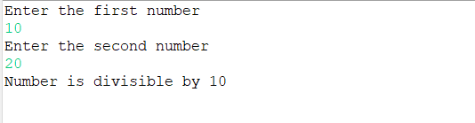

1. Program to find the total salary by hand of an Employee
   1. Class 1 Get basic pay, deduction, and bonus from the console.
   2. Class 2 Calculate hra (5% of basic pay) and pf (20% of basic pay).
   3. Class 3 Find the total salary (basicpay+hra-pf-deduction+bonus) and get the salary slip
   4. Salary slip should contains :- basic pay, deduction, hra, pf, bonus and total salary by hand.

package inheritance;

import java.util.Scanner;

class SalaryEntry {

Double a, b, c;

Double Entry() {

Scanner sc = new Scanner(System.in);

System.out.println("Enter the basic pay");

a = (double) sc.nextInt();

System.out.println("Enter the deduction");

b = (double) sc.nextInt();

System.out.println("Enter the bonus");

c = (double) sc.nextInt();

return a;

}

}

package inheritance;

class SalaryNew extends SalaryEntry {

double hra, pf;

void calc(Double a) {

hra = 0.05 * a;

pf = 0.2 * a;

}

}

package inheritance;

class DisplayDetails extends SalaryNew {

Double Salary;

void finalpr(Double a, Double hra, Double pf, Double b, Double c) {

Salary = (double) (a + hra - pf - b + c);

System.out.println("basic pay: " + a);

System.out.println("deduction: " + b);

System.out.println("hra: " + hra);

System.out.println("pf: " + pf);

System.out.println("bonus: " + c);

System.out.println("Salary after deductions: " + Salary);

}

}

public class SalaryDisplay {

public static void main(String args[]) {

DisplayDetails di = new DisplayDetails();

di.Entry();

di.calc(di.a);

di.finalpr(di.a, di.hra, di.pf, di.b, di.c);

}

}

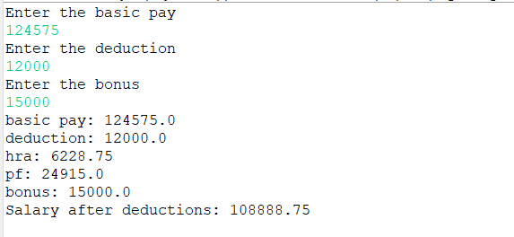

1. Program to calculate discount If customer purchase clothes on Offseason, set discount 15% and on Onseason 40%
   1. • Should use two classes, Onseason and Offseason
   2. • Use two methods- discount(method name should be same)

package inheritance;

import java.util.Scanner;

class Onseason {

Double b, c, d;

void Entry() {

Scanner sc = new Scanner(System.in);

System.out.println("Total price of shopping");

b = (double) sc.nextInt();

c = b * 0.40;

d = b - c;

System.out.println("Total price after discount is:" + d);

}

}

package inheritance;

import java.util.Scanner;

class Offseason extends Onseason {

Double b, c, d;

void Entry() {

Scanner sc = new Scanner(System.in);

System.out.println("Total price of shopping");

b = (double) sc.nextInt();

c = b * 0.15;

d = b - c;

System.out.println("Total price after discount is:" + d);

}

int a;

void discount() {

Scanner sc = new Scanner(System.in);

System.out.println("Enter onseason or offseason as option 1 or 2");

a = (int) sc.nextInt();

if (a == 1) {

super.Entry();

} else if (a == 2) {

Entry();

}

}

}

package inheritance;

import java.util.Scanner;

public class CheckSeason {

public static void main(String args[]) {

Offseason se = new Offseason();

se.discount();

}

}

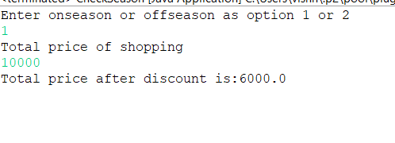

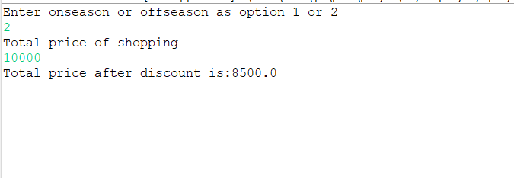

1. Program to calculate the salary
   1. Class 1 : Employee Class – calculateSalary() = Basic+DA+HRA

function,calculateBonus() -Basic * 10% -Super class

* 1. Class 2 : Manager class – call calculateSalary(),calculateBonus()
  2. Class 3 : Accountant class – calculate salary(),calculateBonus()
  3. Class 4: Main class to test the extended class

package inheritance;

import java.util.Scanner;

class Employee {

Double a, b, c, d, e;

Double Entry() {

Scanner sc = new Scanner(System.in);

System.out.println("Employee Salary Details");

System.out.println("Enter the basic pay");

a = (double) sc.nextInt();

System.out.println("Enter the DA");

b = (double) sc.nextInt();

System.out.println("Enter the HRA");

c = (double) sc.nextInt();

d = 0.10 * a;

e = a + b + c + d;

return (e);

}

}

package inheritance;

import java.util.Scanner;

class Manager extends Employee {

Double f, g, h, i, j;

Double mEntry() {

Scanner sc = new Scanner(System.in);

System.out.println("Manager Salary Details");

System.out.println("Enter the basic pay");

f = (double) sc.nextInt();

System.out.println("Enter the DA");

g = (double) sc.nextInt();

System.out.println("Enter the HRA");

h = (double) sc.nextInt();

i = 0.10 * f;

j = f + g + h + i;

return (j);

}

}

package inheritance;

public class Accountant {

public static void main(String args[]) {

Manager ac = new Manager();

ac.Entry();

System.out.println("Bonus of employee is: " + ac.d);

System.out.println("Salary of employee is: " + ac.e);

ac.mEntry();

System.out.println("Bonus of Manager is: " + ac.i);

System.out.println("Salary of Manager is: " + ac.j);

}

}

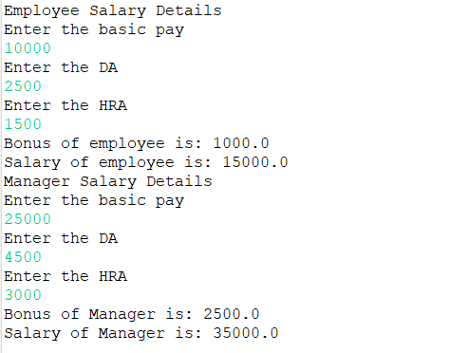

1. Create a class with a method that prints "This is parent class" and its subclass with another method that prints "This is child class". Now, create an object for each of the class and call
   1. class 1 – method of parent class by object of parent class
   2. class 2 - method of child class by object of child class
   3. class 3 - method of parent class by object of child class

package inheritance;

class Parent {

void Entry() {

System.out.println("This is parent class");

}

}

package inheritance;

class Child extends Parent {

void cEntry() {

Child C = new Child();

System.out.println("This is child class");

C.Entry();

}

}

package inheritance;

public class Call {

public static void main(String args[]) {

Parent p = new Parent();

Child C = new Child();

p.Entry();

C.cEntry();

}

}

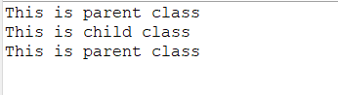

1. Create a class named 'Rectangle' with two data members 'length' and 'breadth' and two methods to print the area and perimeter of the rectangle respectively. Its constructor having parameters for length and breadth is used to initialize length and breadth of the rectangle. Let class 'Square' inherit the 'Rectangle' class with its constructor having a parameter for its side (suppose s) calling the constructor of its parent class as 'super(s,s)'. Print the area and perimeter of a rectangle and a square.

package inheritance;

import java.util.Scanner;

class Rectangle {

int length, breadth, A, P;

int findArea() {

Scanner sc = new Scanner(System.in);

System.out.println("Enter the length");

length = (int) sc.nextInt();

System.out.println("Enter the breadth");

breadth = (int) sc.nextInt();

A = length * breadth;

return A;

}

int findP(int length, int breadth) {

P = 2 * (length + breadth);

return P;

}

}

package inheritance;

class Square extends Rectangle {

int Sa, Pa;

int findSArea() {

{

int i = super.length;

Sa = i * i;

Pa = 4 * i;

return Sa;

}

}

}

package inheritance;

public class DisplayRS extends Square {

public static void main(String args[]) {

DisplayRS D = new DisplayRS();

System.out.println("Area of Rectangle is: " + D.findArea());

System.out.println("Perimeter of Rectangle is: " + D.findP(D.length, D.breadth));

System.out.println("Area of Square is: " + D.findSArea());

System.out.println("Perimeter of Square is:" + D.Pa);

}

}

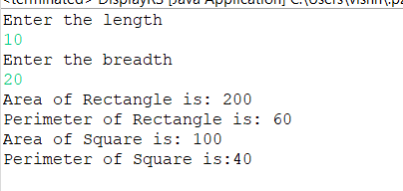

1. Create a class named 'Shape' with a method to print "This is This is shape". Then create two other classes named 'Rectangle', 'Circle' inheriting the Shape class, both having a method to print "This is rectangular shape" and " " respectively. Create a subclass 'Square' of 'Rectangle' having a method to print "Square is a rectangle". Now call the method of 'Shape' and 'Rectangle' class by the object of 'Square' class.

package inheritance;

class Shape {

void DisplayS() {

System.out.println("This is This is shape");

}

}

package inheritance;

class CircleS extends Shape {

void DisplayC() {

System.out.println("This is circular shape");

}

}

package inheritance;

class RectangleS extends Shape {

void DisplayR() {

System.out.println("This is rectangular shape");

}

}

package inheritance;

class SquareS extends RectangleS {

void DisplaySq() {

System.out.println("This is rectangular shape");

}

}

package inheritance;

class SquareNew extends RectangleS {

void DisplaySq() {

System.out.println("Square is a rectangle");

}

}

public class SquareofRectangle {

public static void main(String args[]) {

SquareNew se = new SquareNew();

se.DisplayS();

se.DisplayR();

se.DisplaySq();

}

}

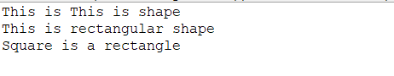

1. Create a class named 'Member' having the following members:  
   Data members
   1. Name
   2. Age
   3. Phone number
   4. Address
   5. Salary
   6. It also has a method named 'printSalary' which prints the salary of the members.

package inheritance;

import java.util.Scanner;

class Member {

String Name;

int Age;

double PhoneN;

double Salary;

String Address;

double Entry() {

Scanner sc = new Scanner(System.in);

System.out.println("Enter Name");

Name = sc.nextLine();

System.out.println("Enter Address");

Address = sc.nextLine();

System.out.println("Enter Age");

Age = sc.nextInt();

System.out.println("Enter Phone Number");

PhoneN = sc.nextDouble();

System.out.println("Enter Salary");

Salary = sc.nextDouble();

return Salary;

}

void PrintSalary() {

System.out.println("Salary is :" + Salary);

}

}

package inheritance;

class MemberCheck extends Member {

public static void main(String args[]) {

MemberCheck M = new MemberCheck();

M.Entry();

M.PrintSalary();

}

}

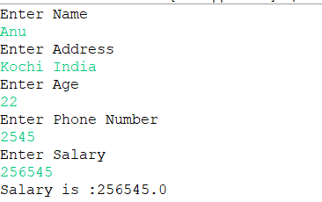

1. Two classes 'Employee' and 'Manager' inherits the 'Member' class. The 'Employee' and 'Manager' classes have data members 'specialization' and 'department' respectively. Now, assign name, age, phone number, address and salary to an employee and a manager by making an object of both of these classes and print the same.

package inheritance;

import java.util.Scanner;

class EmployeeNew {

String Name, Address, Sp, Dp;

Double a, b, c, d, e, Age, PhoneN;

Double Entry() {

Scanner sc = new Scanner(System.in);

System.out.println("Employee Details");

System.out.println("Enter Specialization");

Sp = sc.nextLine();

System.out.println("Enter Department");

Dp = sc.nextLine();

System.out.println("Enter Address");

Address = sc.nextLine();

System.out.println("Enter Age");

Age = (double) sc.nextInt();

System.out.println("Enter Phone Number");

PhoneN = (double) sc.nextInt();

System.out.println("Employee Salary Details");

System.out.println("Enter the basic pay");

a = (double) sc.nextInt();

System.out.println("Enter the DA");

b = (double) sc.nextInt();

System.out.println("Enter the HRA");

c = (double) sc.nextInt();

d = 0.10 * a;

e = a + b + c + d;

return (e);

}

}

package inheritance;

import java.util.Scanner;

class ManagerNew extends EmployeeNew {

String Name, Address, Sp, Dp;

Double a, b, c, d, e, Age, PhoneN;

Double EntryM() {

Scanner sc = new Scanner(System.in);

System.out.println("Manager Details");

System.out.println("Enter Specialization");

Sp = sc.nextLine();

System.out.println("Enter Department");

Dp = sc.nextLine();

System.out.println("Enter Address");

Address = sc.nextLine();

System.out.println("Enter Age");

Age = (double) sc.nextInt();

System.out.println("Enter Phone Number");

PhoneN = (double) sc.nextInt();

System.out.println("Manager Salary Details");

System.out.println("Enter the basic pay");

a = (double) sc.nextInt();

System.out.println("Enter the DA");

b = (double) sc.nextInt();

System.out.println("Enter the HRA");

c = (double) sc.nextInt();

d = 0.10 * a;

e = a + b + c + d;

return e;

}

}

package inheritance;

class AccountantNew extends ManagerNew {

public static void main(String args[]) {

AccountantNew AN = new AccountantNew();

System.out.println("Employee Salary is :" + AN.Entry());

System.out.println("Manager Salary is :" + AN.EntryM());

}

}

